**Hardware Requirements:**

**1 Arduino Mega 2560**

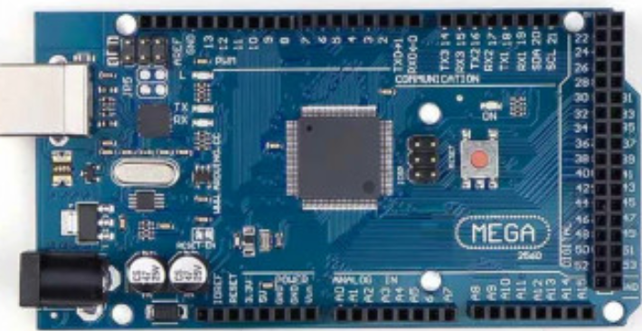

**Fig: 2.1.1.a Arduino Mega**

* Arduino is a microcontroller board based on the ATmega2560. It has 54 digital I/O pins, 16 analog inputs, 4 UARTs, a 16 MHz crystal oscillator, a USB connection, a power jack, an ICSP header, and a reset button.It is an open-source electronic platform based on easy-to-use hardware and software.
* The boards feature serial communications interfaces, including Universal Serial Bus (USB), which are also used for loading programs. The microcontrollers can be programmed using the C and C++ programming languages

**Power:**

The Arduino Mega can be powered via the USB connection or with an external power supply. The power source is selected automatically.

The power pins are as follows:

* VIN-The input voltage to the Arduino board when it's using an external power source.
* 5V -This pin outputs a regulated 5V from the regulator on the board.

**Memory:**

The ATmega2560 has256 KB of flash memory for storing code, 8 KB is used for the boot-loader, 8 KB of SRAM, 4 KB of EEPROM which can be read and written with the EEPROM library

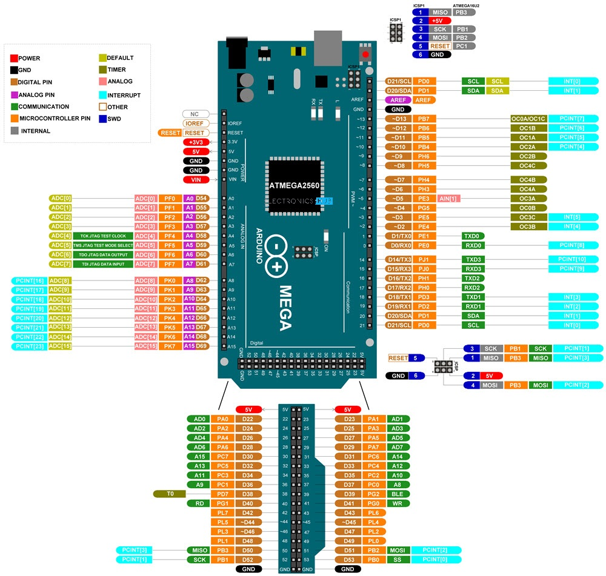

**Fig: 2.1.1.b Arduino Mega Pin Configuration**

**Input and Output:**

* Each of the 54 digital pins on the Mega can be used as an input or output, using pinMode(), digitalWrite() and digitalRead() functions.
* Some pins have specialized functions: Serial 0 (RX) and 1 (TX), Serial 1 19 (RX) and18 (TX), Serial 2 17 (RX) and 16 (TX), Serial 3 15 (RX) and 14 (TX) used to receive (RX) and transmit (TX) TTL serial data.
* External Interrupts: - 2 (interrupt 0), 3(interrupt 1), 18 (interrupt 5), 19 (interrupt4), 20 (interrupt 3), and 21 (interrupt 2). These pins can be configured to trigger an interrupt on a low value, a rising or falling edge, or a change in value.
* PWM 2 to 13 and 44 to 46. Provide 8-bit PWM output with the analogWrite() function.
* LED 13. It is a built-in LED connected to digital pin 13. When the pin is HIGH value, the LED is on, when the pin is LOW, it's off.
* TWI 20 (SDA) and 21 (SCL). Support TWI communication using the Wire library.

**Communication:**

* The Atmega2560 provides four hardware UARTs for TTL (5V) serial communication.
* The Arduino software includes a serial monitor which allows simple textual data to be sent to and from the board.

1. **Motor Driver L298N**

* The L298N is a dual H-Bridge motor driver which allows speed and direction control of two DC motors at the same time. The module can drive DC motors that have voltages between 5 and 35V, with a peak current up to 2A.
* Motor drivers act as an interface between the motors and the control circuits. Motor require high amount of current whereas the controller (Arduino mega) circuit works on low current signals. So the function of motor drivers is to take a low-current control signal and then turn it into a higher-current signal that can drive a motor.

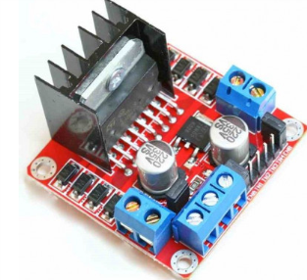

**Fig:2.1.2.a Motor Driver L298N**

**PIN DIAGRAM of L298N:**

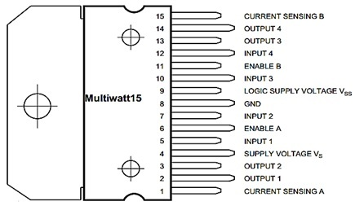

**Fig:2.1.2.b pin diagram of Motor Driver L298N**

**Motor Driver Internal Circuit:**

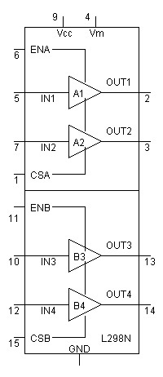

**Fig:2.1.2.c Motor Driver internal circuit**

**WORKING:**

* Inputs: ENA can select two amplifiers A1, A2 and similarly ENB can select two amplifiers B1, B2. While using as a bridge circuit, ENA selects bridge A and ENB selects bridge B. To drive both the motors by using H bridges, both enable bits are set high.
* Outputs**:** There are four outputs. The output for motor A is obtained from out1 & out2 pins and similarly for motor B output is obtained from out3 &out4 pins.
* L298N does not have built in protection diodes we used external diodes to prevent the IC from getting damaged.
* This IC is using two different voltages. On input side, 5v is given to the pin 9 (Vss), push buttons and enable bits. On output side, pin 4 (Vs) supplies the motors and it can be up to 35v grounded those pins 1 & 15. Motors speed will be lower if low voltages are on output side.

1. **Wi-Fi Module (ESP8266):**

* Wi-Fi module belongs to transmission layer of IOT. Its function is to convert serial port or TTL level into embedded module. A typical wireless router in an indoor point-to-multipoint arrangement using 802.11n
* The ESP8266 Wi-Fi Module is a self-contained SOC with integrated TCP/IP protocol stack. It can give any microcontroller access to the connected Wi-Fi network.
* The ESP8266 is capable of either hosting an application or offloading all Wi-Fi networking functions from another application processor.
* In this project Wi-Fi module is used to send an alert message to the control station through mail.
* ESP8266 can be used as an external Wi-Fi module, using the standard AT Command set Firmware by connecting it to any microcontroller using the serial UART, or directly serve as a Wi-Fi-enabled micro controller, by programming a new firmware using the provided SDK.
* The GPIO pins allow Analog and Digital IO, PWM, SPI, I2C, etc.
* This board has been around for almost a year now, and has been used mostly in IOT contexts, where add connectivity for example to an Arduino project. A wide adoption has been facilitated by the very modest price, ranging from 2.50 to 10 USD depending on the features offered by the manufacturers.

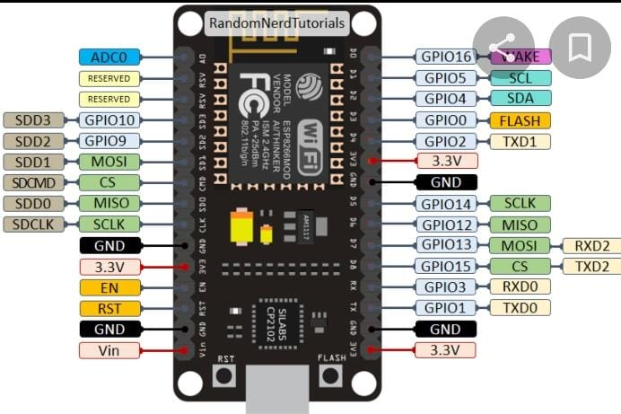

**Fig: 2.1.3(a) module Wi-Fi (ESP8266)**

**Specifications**:

* 802.11 n / g /
* Wi-Fi Direct (P2P), soft-AP
* Built-in TCP / IP protocol stack
* Built-in PLL, voltage regulator and power management components
* Off leakage current is less than 10uA

**Using the ESP8266 with Arduino:**

* Several [Libraries](https://github.com/sleemanj/ESP8266_Simple)have been developed to use ESP8266 as a module for Arduino. Also there is a port of the Arduino IDE for programming the ESP Directly.

**Using the ESP8266 via Serial port**

* It can interact with the ESP8266 sending AT Commands via the provided TX and RX pins by using another microcontroller.

**Programming the ESP8266 Directly**

* In order to program the ESP directly need to install a tool chain and firmware upload utility.

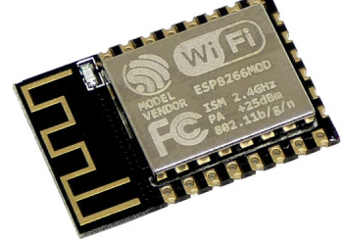

**Fig:2.1.3(b) Wi-Fi Module (ESP8266)**

1. **IR Sensor:**

* IR sensor is an electronic device, that emits the light in order to sense some object of the surroundings. An IR sensor detects object
* Active infrared sensors work with radar technology and they both emit and receive infrared radiation.
* This radiation hits the objects nearby and bounces back to the receiver of the device.
* The pins that are present on the IR Sensor include the Ground, the Vcc and the Signal pins. The role of the Ground and the Vcc is to power the sensor.
* An IR sensor consists of an IR LED and an IR Photodiode together they are called as Photo – Coupler. There are five basic elements used in a typical infrared detection system an infrared source, a transmission medium, optical component, infrared detectors or receivers and signal processing.
* Infrared lasers and Infrared LEDs of specific wavelength used as infrared sources.
* The emitter is simply an IR LED (Light Emitting Diode) and the detector is simply an IR photodiode. Photodiode is sensitive to IR light of the same wavelength which is emitted by the IR LED. When IR light falls on the photodiode, the resistance and the output voltages will change in proportion to the magnitude of the IR light received.

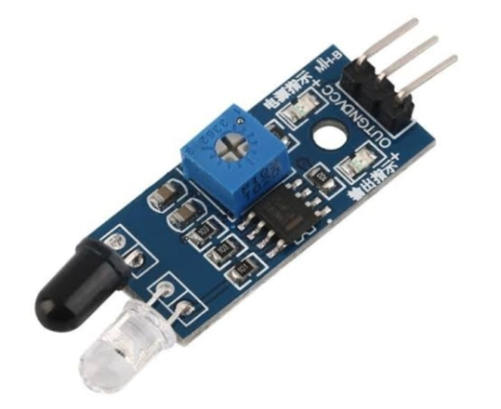 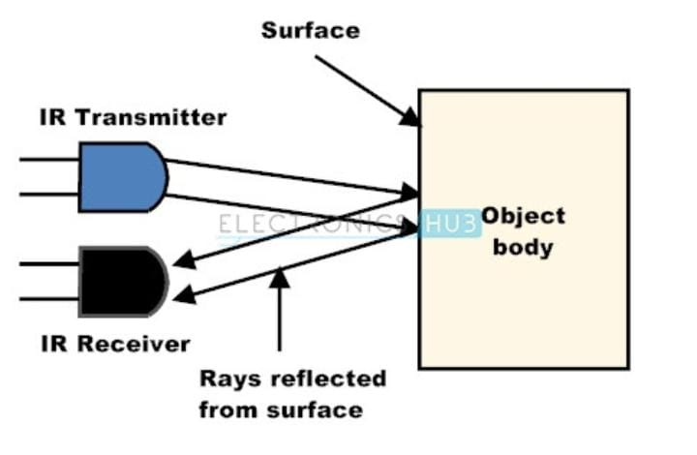  **Fig: 2.1.4 IR Sensor**

1. **Bluetooth Module:**

* The Bluetooth module is a small range wireless communication device that can be used for various purposes like sending of data or controlling of devices connected with it.
* The Arduino Bluetooth module receives the data from the in-built Bluetooth android application and sends it to the Arduino through the TX pin of the Bluetooth module.
* It uses the 2.45GHz frequency band. The transfer rate of the data can vary up to 1Mbps and is in range of 10 meters.

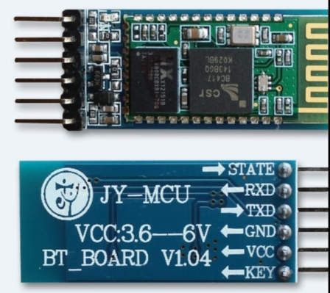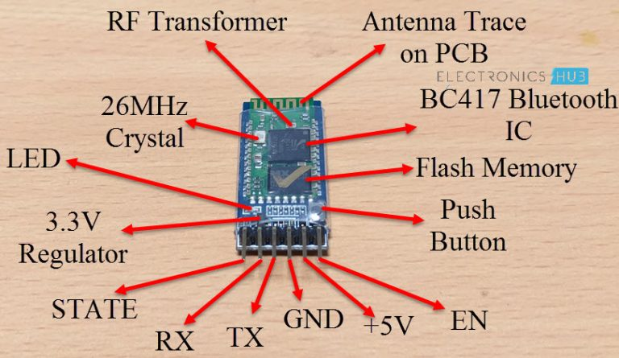

**Fig:2.1.5 Bluetooth Module**

Pin Description

EN: It is the enable pin. When this pin is floating or connected to 3.3V, the module is enabled. If this pin is connected to GND, the module is disabled.

+5V: This is the supply pin for connecting +5V. As the Module has on-board 3.3V regulator, you can provide +5V supply.

GND: It is the ground pin.

TX: It is the Transmitter pin of the UART Communication.

RX: It is the Receive Pin of UART.

STATE: This is a status indicator pin. This pin goes LOW when the module is not connected to any device. When the module is paired with any device, this pin goes HIGH.

**Mode of operation**

In Command Mode, you can communicate with the Bluetooth module through AT Commands for configuring various settings and parameters of the Module like get the firmware information, change UART Baud Rate, change module name, set it as either Master or slave etc.

An important point about HC-05 Module is that it can be configured as Master or Slave in a communication pair. In order to select either of the modes, you need to activate the Command Mode and sent appropriate AT Commands

Coming to the Data Mode, in this mode, the module is used for communicating with other Bluetooth device i.e. data transfer happens in this mode.

**Default Settings of HC-05 Bluetooth Module**

Name: HC-05

Password: 1234 (or 0000)

Type: Slave

Mode: Data

Baud Rate: 9600 with 8 data bits, no parity and 1 stop bit

**Software Specifications:**

1. **Arduino IDE**

* The Arduino software (IDE) is open source software, which is used to program the Arduino boards, and is an integrated development environment, developed by [arduino.cc](https://www.arduino.cc/). It allows writing, uploads code to Arduino boards and consists of many libraries with set of examples.
* The Arduino software is easy to use for beginners, or advanced users. It uses to get started with electronics programming, robotics, and build interactive prototypes.
* Programs written using Arduino Software (IDE) are called sketches. These sketches are written in the text editor and are saved with the file extension .ino. The editor has features for cutting/pasting and for searching/replacing text.
* The message area gives feedback while saving and exporting and also displays errors. The console displays text output by the Arduino Software (IDE), including complete error messages and other information.

**2.2.1 Arduino IDE Interface**

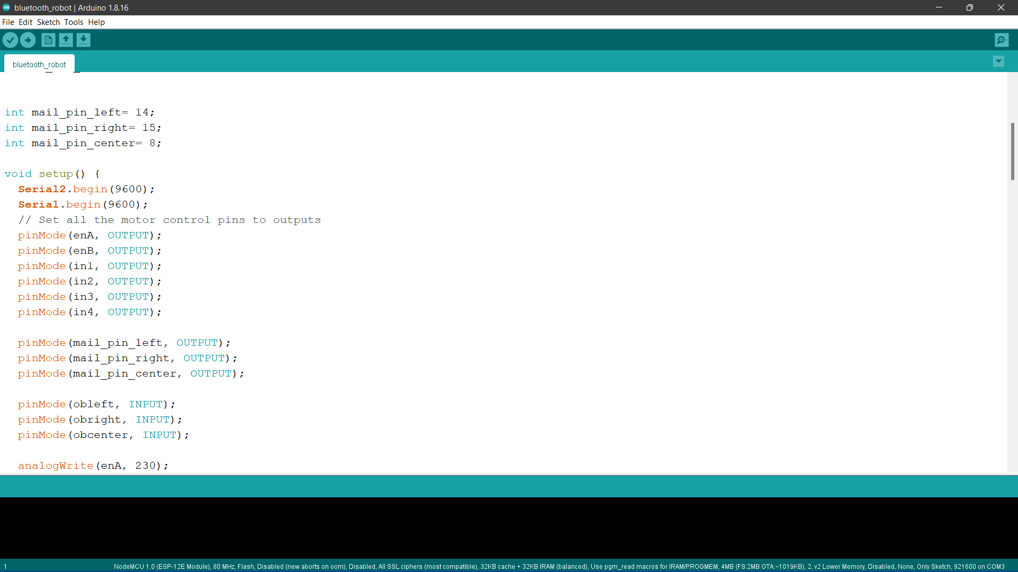

1. **Motor Driver Operation:**

Motor drivers acts as an interface between the motors and the control circuits. The rotation direction is controlled by the control pin IN1 and IN2 for motor 1 while control pin IN3 and IN4 for motor 2.

|  |  |  |
| --- | --- | --- |
| **IN1** | **IN2** | **Direction** |
| 0 | 0 | OFF |
| 1 | 0 | Forward |
| 0 | 1 | Backward |
| 1 | 1 | OFF |

**2.2.3 IP Webcam**

* IP Webcam is an app that allows to convert Android device camera into an internet camera with multiple view options that can be seen on any platform using VLC player or an internet browser.
* Configuration:

Initially, enable the Wi-Fi of the camera, find the right app(IP Webcam), set it up, then place the camera on board. The result in a steady IP webcam picture can be streamed across the web. The footage can be viewed in any web browser by using the IP address of the camera.

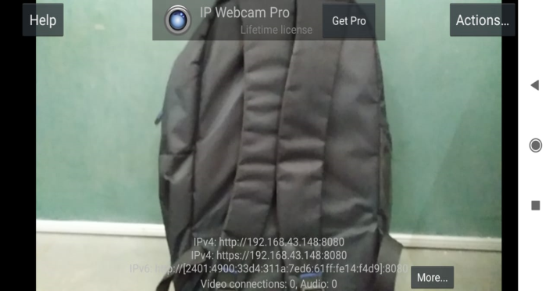

Fig 2.2.3 screenshot of webcam

1. **Bluetooth Pair App HC-05**

* Bluetooth is a one of the great example for wireless connectivity. It is used in many fields. Bluetooth consumes very small amount of energy.
* Bluetooth Module (HC-05) is interfaced with Arduino Mega 2560 microcontroller board.
* Bluetooth Module communicate in full-duplex mode. It can be interfaced with most of the microcontrollers as it operates through Serial Port Protocol (SSP).

Technical Specifications:

* Operating Voltage: 4V to 6V (Typically +5V).
* Operating Current: 30mA.
* Range: less than 100m.
* Works with Serial communication (USART) and TTL compatible.
* Can be easily interfaced with Laptop or Mobile phones with Bluetooth.

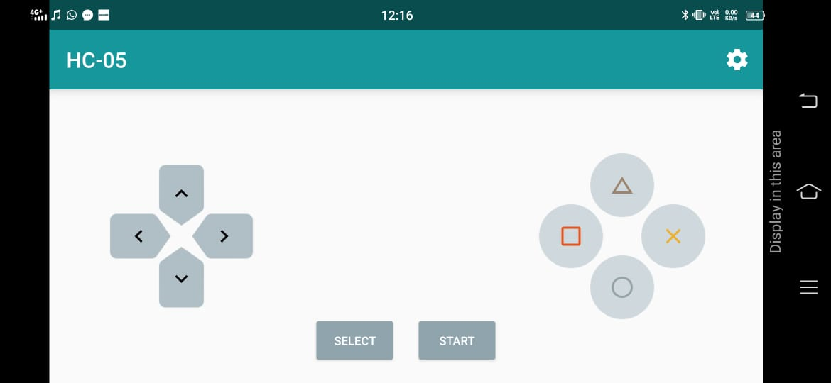

Fig 2.2.4 Bluetooth pair app screenshot